Specification File of AFCS

Document generated automatically by M2Doc from Capella model of the system

# Tables of Content

**Aucune entrée de table des matières n'a été trouvée.**

# Description of the system Missions

*No mission defined*

# Description of the system Capabilities

# Description of the System and its Environment

## Architecture Blank Diagrams

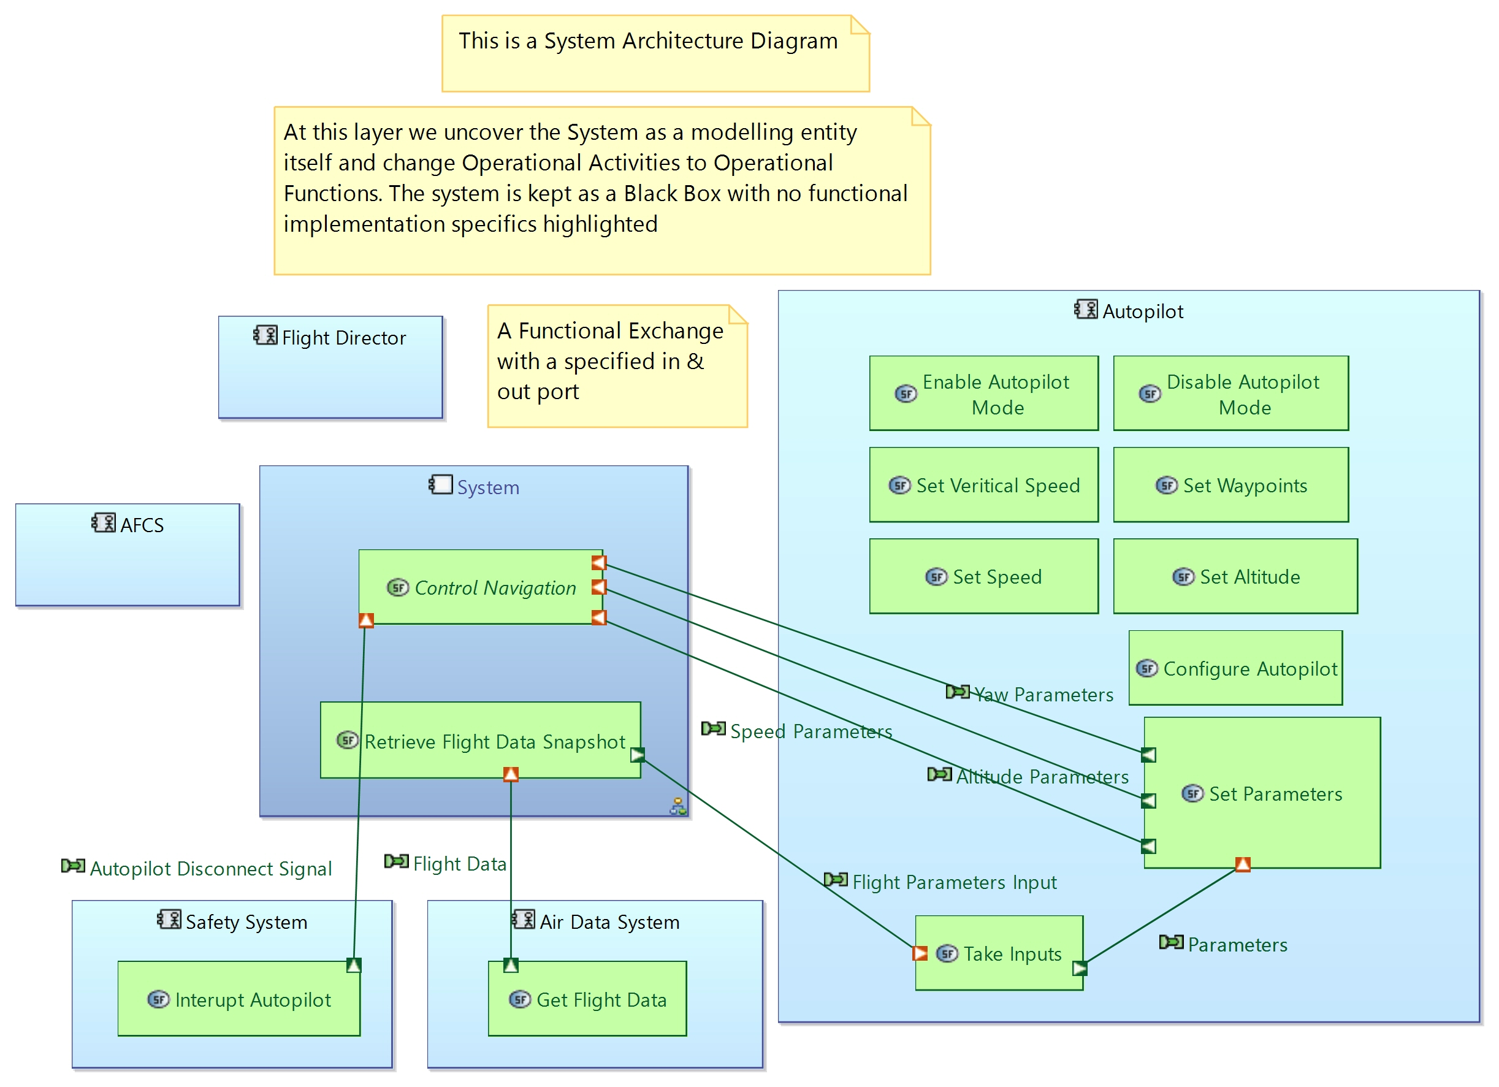

## System: System

Modes & State Machines:

* System State Machine

Allocated functions:

* **Retrieve Flight Data Snapshot**
* **Set Yaw Damper Mode**
* **Automatic Landing**
* **Set Pitch Trim**

## Actor: Safety System

Modes & State Machines:

*No modes & states machine*

Allocated functions:

* **Interupt Autopilot**

## Actor: Flight Director

Modes & State Machines:

*No modes & states machine*

Allocated functions:

*No allocated function*

## Actor: AFCS

Modes & State Machines:

*No modes & states machine*

Allocated functions:

*No allocated function*

## Actor: Autopilot

Modes & State Machines:

*No modes & states machine*

Allocated functions:

* **Enable Autopilot Mode**
* **Disable Autopilot Mode**
* **Set Veritical Speed**
* **Set Waypoints**
* **Set Speed**
* **Set Altitude**
* **Configure Autopilot**
* **Take Inputs**
* **Set Parameters**

## Actor: Air Data System

Modes & State Machines:

*No modes & states machine*

Allocated functions:

* **Get Flight Data**

# Description of the Functions

The Functions are sorted in the following packages:

|  |  |  |
| --- | --- | --- |
| **Parent element** | **Function package** | **Contained functions** |
| System Functions | Root System Function | **Set Flight Path**  **Configure Autopilot**  **Control Navigation**  **Interupt Autopilot**  **Get Flight Data**  **Disable Autopilot Mode**  **Enable Autopilot Mode**  **Retrieve Flight Data Snapshot** |

## Function: Set Flight Path

Description:

Parent / Children functions:

|  |  |  |
| --- | --- | --- |
| **Parent function** | **Current function** | **Children functions** |
| **Root System Function** | Set Flight Path | * **Set Altitude** * **Set Waypoints** * **Set Speed** * **Set Veritical Speed** * **Take Inputs** * **Set Parameters** |

List of inputs:

*No input*

List of outputs:

*No output*

Participation to functional chains:

*None*

Allocated to:

*Function not allocated*

## Function: Set Altitude

Description:

*No description*

Parent / Children functions:

|  |  |  |
| --- | --- | --- |
| **Parent function** | **Current function** | **Children functions** |
| **Set Flight Path** | Set Altitude | *No children function* |

List of inputs:

*No input*

List of outputs:

*No output*

Participation to functional chains:

*None*

Allocated to:

* **Autopilot**

## Function: Set Waypoints

Description:

*No description*

Parent / Children functions:

|  |  |  |
| --- | --- | --- |
| **Parent function** | **Current function** | **Children functions** |
| **Set Flight Path** | Set Waypoints | *No children function* |

List of inputs:

*No input*

List of outputs:

*No output*

Participation to functional chains:

*None*

Allocated to:

* **Autopilot**

## Function: Set Speed

Description:

*No description*

Parent / Children functions:

|  |  |  |
| --- | --- | --- |
| **Parent function** | **Current function** | **Children functions** |
| **Set Flight Path** | Set Speed | *No children function* |

List of inputs:

*No input*

List of outputs:

*No output*

Participation to functional chains:

*None*

Allocated to:

* **Autopilot**

## Function: Set Veritical Speed

Description:

*No description*

Parent / Children functions:

|  |  |  |
| --- | --- | --- |
| **Parent function** | **Current function** | **Children functions** |
| **Set Flight Path** | Set Veritical Speed | *No children function* |

List of inputs:

*No input*

List of outputs:

*No output*

Participation to functional chains:

*None*

Allocated to:

* **Autopilot**

## Function: Take Inputs

Description:

*No description*

Parent / Children functions:

|  |  |  |
| --- | --- | --- |
| **Parent function** | **Current function** | **Children functions** |
| **Set Flight Path** | Take Inputs | *No children function* |

List of inputs:

| **Incoming functional exchange** | **Exchanged items** |
| --- | --- |

|  |  |
| --- | --- |
| Flight Parameters Input | *No exchanged item* |

List of outputs:

| **Outgoing functional exchange** | **Exchanged items** |
| --- | --- |

|  |  |
| --- | --- |
| Parameters | *No exchanged item* |

Participation to functional chains:

* **Configure Speed Parameters**
* **Configure Altitude Parameters**
* **Configure Yaw Parameters**

Allocated to:

* **Autopilot**

## Function: Set Parameters

Description:

*No description*

Parent / Children functions:

|  |  |  |
| --- | --- | --- |
| **Parent function** | **Current function** | **Children functions** |
| **Set Flight Path** | Set Parameters | *No children function* |

List of inputs:

| **Incoming functional exchange** | **Exchanged items** |
| --- | --- |

|  |  |
| --- | --- |
| Parameters | *No exchanged item* |

List of outputs:

| **Outgoing functional exchange** | **Exchanged items** |
| --- | --- |

|  |  |
| --- | --- |
| Speed Parameters | *No exchanged item* |

|  |  |
| --- | --- |
| Altitude Parameters | *No exchanged item* |

|  |  |
| --- | --- |
| Yaw Parameters | *No exchanged item* |

Participation to functional chains:

* **Configure Speed Parameters**
* **Configure Altitude Parameters**
* **Configure Yaw Parameters**

Allocated to:

* **Autopilot**

## Function: Configure Autopilot

Description:

*No description*

Parent / Children functions:

|  |  |  |
| --- | --- | --- |
| **Parent function** | **Current function** | **Children functions** |
| **Root System Function** | Configure Autopilot | *No children function* |

List of inputs:

*No input*

List of outputs:

*No output*

Participation to functional chains:

*None*

Allocated to:

* **Autopilot**

## Function: Control Navigation

Description:

*No description*

Parent / Children functions:

|  |  |  |
| --- | --- | --- |
| **Parent function** | **Current function** | **Children functions** |
| **Root System Function** | Control Navigation | * **Set Yaw Damper Mode** * **Automatic Landing** * **Set Pitch Trim** |

List of inputs:

| **Incoming functional exchange** | **Exchanged items** |
| --- | --- |

|  |  |
| --- | --- |
| Autopilot Disconnect Signal | *No exchanged item* |

List of outputs:

*No output*

Participation to functional chains:

*None*

Allocated to:

*Function not allocated*

## Function: Set Yaw Damper Mode

Description:

*No description*

Parent / Children functions:

|  |  |  |
| --- | --- | --- |
| **Parent function** | **Current function** | **Children functions** |
| **Control Navigation** | Set Yaw Damper Mode | *No children function* |

List of inputs:

| **Incoming functional exchange** | **Exchanged items** |
| --- | --- |

|  |  |
| --- | --- |
| Yaw Parameters | *No exchanged item* |

List of outputs:

*No output*

Participation to functional chains:

* **Configure Yaw Parameters**

Allocated to:

* **System**

## Function: Automatic Landing

Description:

*No description*

Parent / Children functions:

|  |  |  |
| --- | --- | --- |
| **Parent function** | **Current function** | **Children functions** |
| **Control Navigation** | Automatic Landing | *No children function* |

List of inputs:

*No input*

List of outputs:

*No output*

Participation to functional chains:

*None*

Allocated to:

* **System**

## Function: Set Pitch Trim

Description:

*No description*

Parent / Children functions:

|  |  |  |
| --- | --- | --- |
| **Parent function** | **Current function** | **Children functions** |
| **Control Navigation** | Set Pitch Trim | *No children function* |

List of inputs:

| **Incoming functional exchange** | **Exchanged items** |
| --- | --- |

|  |  |
| --- | --- |
| Altitude Parameters | *No exchanged item* |

|  |  |
| --- | --- |
| Speed Parameters | *No exchanged item* |

List of outputs:

*No output*

Participation to functional chains:

* **Configure Speed Parameters**
* **Configure Altitude Parameters**

Allocated to:

* **System**

## Function: Interupt Autopilot

Description:

*No description*

Parent / Children functions:

|  |  |  |
| --- | --- | --- |
| **Parent function** | **Current function** | **Children functions** |
| **Root System Function** | Interupt Autopilot | *No children function* |

List of inputs:

*No input*

List of outputs:

| **Outgoing functional exchange** | **Exchanged items** |
| --- | --- |

|  |  |
| --- | --- |
| Autopilot Disconnect Signal | *No exchanged item* |

Participation to functional chains:

*None*

Allocated to:

* **Safety System**

## Function: Get Flight Data

Description:

*No description*

Parent / Children functions:

|  |  |  |
| --- | --- | --- |
| **Parent function** | **Current function** | **Children functions** |
| **Root System Function** | Get Flight Data | *No children function* |

List of inputs:

*No input*

List of outputs:

| **Outgoing functional exchange** | **Exchanged items** |
| --- | --- |

|  |  |
| --- | --- |
| Flight Data | *No exchanged item* |

Participation to functional chains:

* **Configure Speed Parameters**
* **Configure Altitude Parameters**
* **Configure Yaw Parameters**

Allocated to:

* **Air Data System**

## Function: Disable Autopilot Mode

Description:

*No description*

Parent / Children functions:

|  |  |  |
| --- | --- | --- |
| **Parent function** | **Current function** | **Children functions** |
| **Root System Function** | Disable Autopilot Mode | *No children function* |

List of inputs:

*No input*

List of outputs:

*No output*

Participation to functional chains:

*None*

Allocated to:

* **Autopilot**

## Function: Enable Autopilot Mode

Description:

*No description*

Parent / Children functions:

|  |  |  |
| --- | --- | --- |
| **Parent function** | **Current function** | **Children functions** |
| **Root System Function** | Enable Autopilot Mode | *No children function* |

List of inputs:

*No input*

List of outputs:

*No output*

Participation to functional chains:

*None*

Allocated to:

* **Autopilot**

## Function: Retrieve Flight Data Snapshot

Description:

*No description*

Parent / Children functions:

|  |  |  |
| --- | --- | --- |
| **Parent function** | **Current function** | **Children functions** |
| **Root System Function** | Retrieve Flight Data Snapshot | *No children function* |

List of inputs:

| **Incoming functional exchange** | **Exchanged items** |
| --- | --- |

|  |  |
| --- | --- |
| Flight Data | *No exchanged item* |

List of outputs:

| **Outgoing functional exchange** | **Exchanged items** |
| --- | --- |

|  |  |
| --- | --- |
| Flight Parameters Input | *No exchanged item* |

Participation to functional chains:

* **Configure Speed Parameters**
* **Configure Altitude Parameters**
* **Configure Yaw Parameters**

Allocated to:

* **System**

# Description of the Functional Chains

## Functional Chain : Configure Speed Parameters

This functional chain is illustrated by the following diagram:

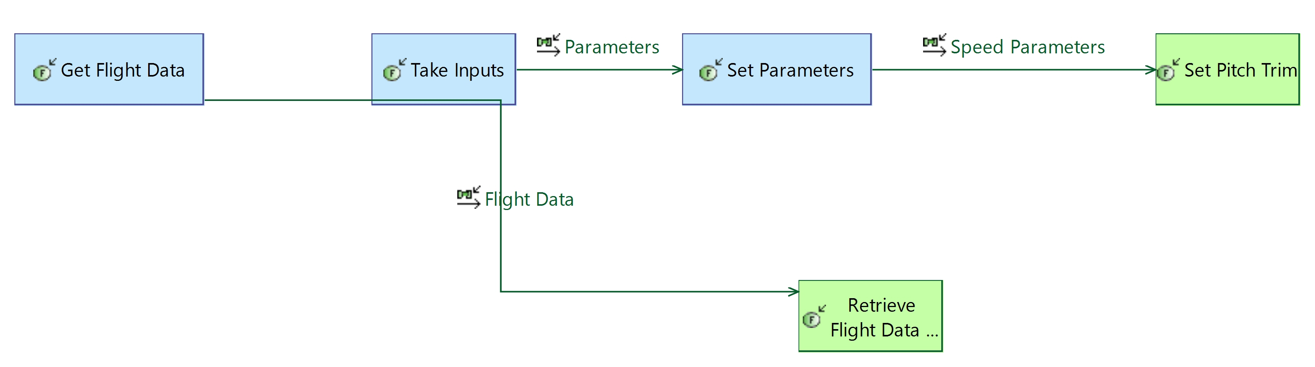

Description:

*No description*

Involved elements:

This functional chain involves the following elements:

| **Functional exchange** | **Source function** | **Target function** |
| --- | --- | --- |

|  |  |  |
| --- | --- | --- |
| Flight Data | **Get Flight Data** | **Retrieve Flight Data Snapshot** |

|  |  |  |
| --- | --- | --- |
| Parameters | **Take Inputs** | **Set Parameters** |

|  |  |  |
| --- | --- | --- |
| Speed Parameters | **Set Parameters** | **Set Pitch Trim** |

Involving capabilities:

*No involving capability*

## Functional Chain : Configure Altitude Parameters

Description:

*No description*

Involved elements:

This functional chain involves the following elements:

| **Functional exchange** | **Source function** | **Target function** |
| --- | --- | --- |

|  |  |  |
| --- | --- | --- |
| Flight Data | **Get Flight Data** | **Retrieve Flight Data Snapshot** |

|  |  |  |
| --- | --- | --- |
| Parameters | **Take Inputs** | **Set Parameters** |

|  |  |  |
| --- | --- | --- |
| Altitude Parameters | **Set Parameters** | **Set Pitch Trim** |

Involving capabilities:

*No involving capability*

## Functional Chain : Configure Yaw Parameters

Description:

*No description*

Involved elements:

This functional chain involves the following elements:

| **Functional exchange** | **Source function** | **Target function** |
| --- | --- | --- |

|  |  |  |
| --- | --- | --- |
| Flight Data | **Get Flight Data** | **Retrieve Flight Data Snapshot** |

|  |  |  |
| --- | --- | --- |
| Parameters | **Take Inputs** | **Set Parameters** |

|  |  |  |
| --- | --- | --- |
| Yaw Parameters | **Set Parameters** | **Set Yaw Damper Mode** |

Involving capabilities:

*No involving capability*

# Description of Scenarios

*No scenario defined*

# Data definition

## Data

## Predefined Types

Data types definition:

* Boolean
* Byte
* Char
* Double
* Float
* Hexadecimal
* Integer
* Long
* LongLong
* Short
* String
* UnsignedInteger
* UnsignedShort
* UnsignedLong
* UnsignedLongLong